OUR PRODUCT
Three categories of premium betel nut varieties, each processed to exacting standards that meet the demands of international buyers.
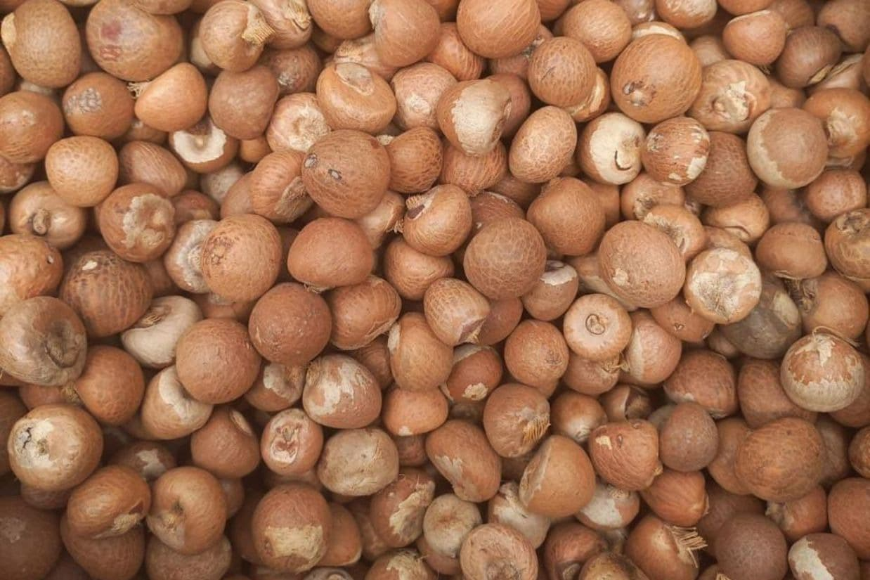
WHOLE BETEL NUT (PINANG BULAT KERING)
High-quality dried whole betel nuts processed from selected fruits. Undergoes strict sorting and optimal drying to ensure long shelf life and international export standards.
- Moisture Content: Max 5%
- Good Cut/Density: Min. 90% (Dense seeds,not hollow)
- Fungus Free: 100% (Aflatoxin controlled)
- Quality Grade: 85-90 90-95 95++ (Based on maturity)
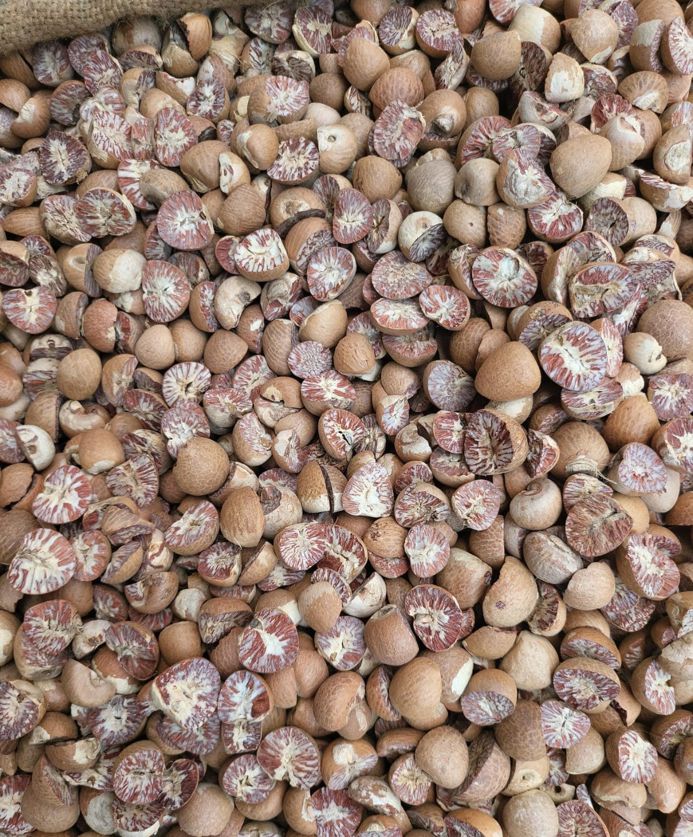
SPLIT BETEL NUT (PINANG BELAH)
Precisely split betel nuts, allowing easy internal quality verification. Perfectly suited as raw material for pharmaceutical industries and traditional consumption in global markets.
- Moisture Content: 0-3% 3-5%
- Good Cut/Density: Min. 90% (Dense seeds,not hollow)
- Fungus Free: 100% (Aflatoxin controlled)
- Quality Grade: 85-90 90-95 95++ (Roasted)
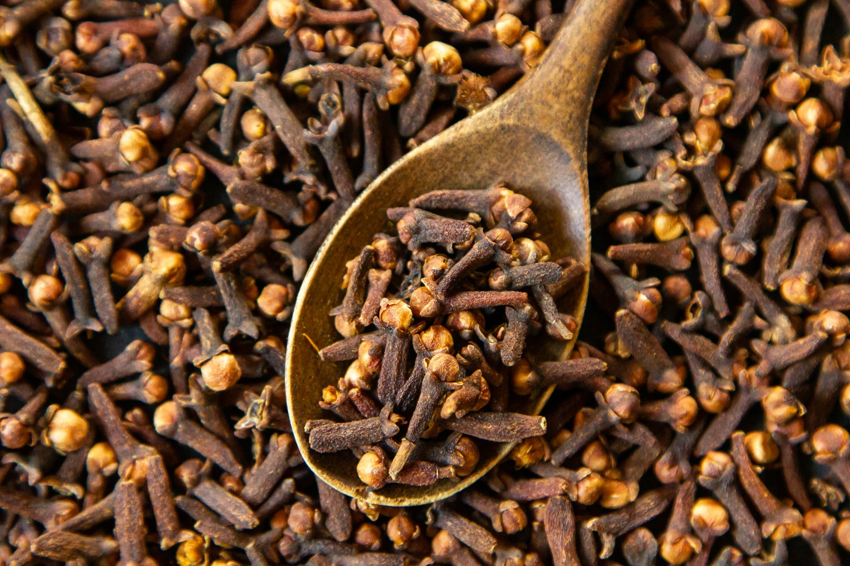
CLOVE (CENGKEH)
Premium quality dried cloves sourced from Indonesia's finest plantations. Known for their strong aroma and high essential oil content, perfect for culinary and pharmaceutical applications.
- Moisture Content: Max 14%
- Essential Oil Content: Min. 17%
- Purity: 99% (Free from stems and foreign matter)
- Quality Grade: Premium Export Grade

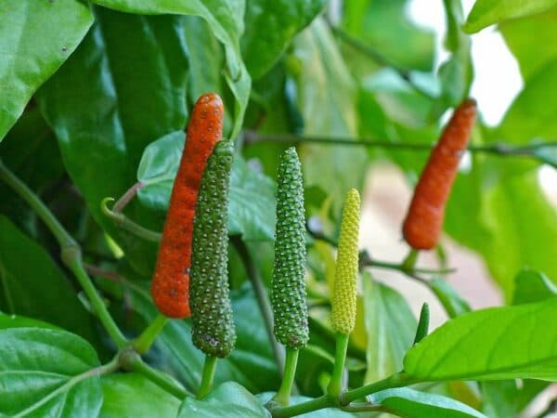
LONG PEPPER (CABE JAWA)
Traditional Indonesian long pepper with distinctive spicy flavor. Highly valued in traditional medicine and gourmet cuisine for its unique taste profile and health benefits.
- Moisture Content: Max 12%
- Piperine Content: Min. 4%
- Length: 2-5 cm (Premium grade)
- Quality Grade: Export Standard

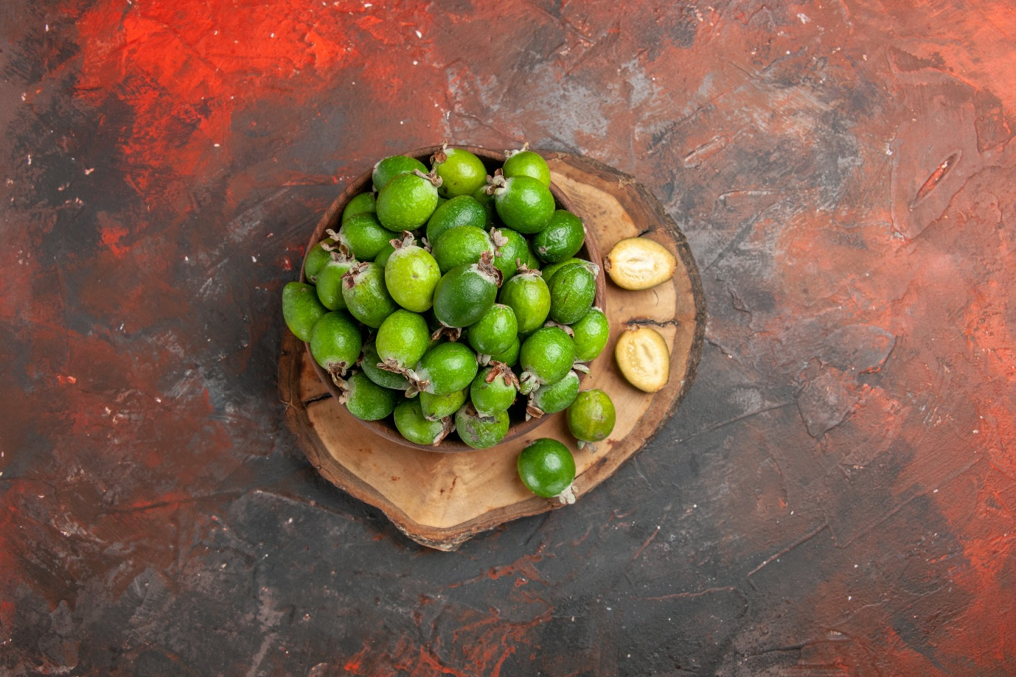
NUTMEG (BUAH PALA)
Whole dried nutmeg from premium Indonesian plantations. Rich in essential oils and aromatic compounds, ideal for spice trade and food processing industries.
- Moisture Content: Max 10%
- Essential Oil Content: Min. 8%
- Size: 110-120 pieces per kg
- Quality Grade: ABCD Grade Available

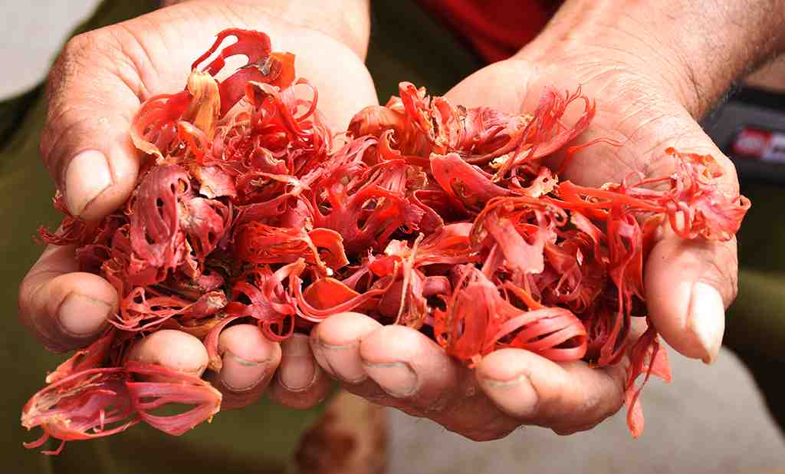
MACE (BUNGA PALA)
Premium dried mace, the delicate outer covering of nutmeg. Prized for its subtle flavor and vibrant color, essential for high-end culinary applications.
- Moisture Content: Max 12%
- Color: Bright Orange-Red
- Essential Oil Content: Min. 10%
- Quality Grade: Whole Blade Premium

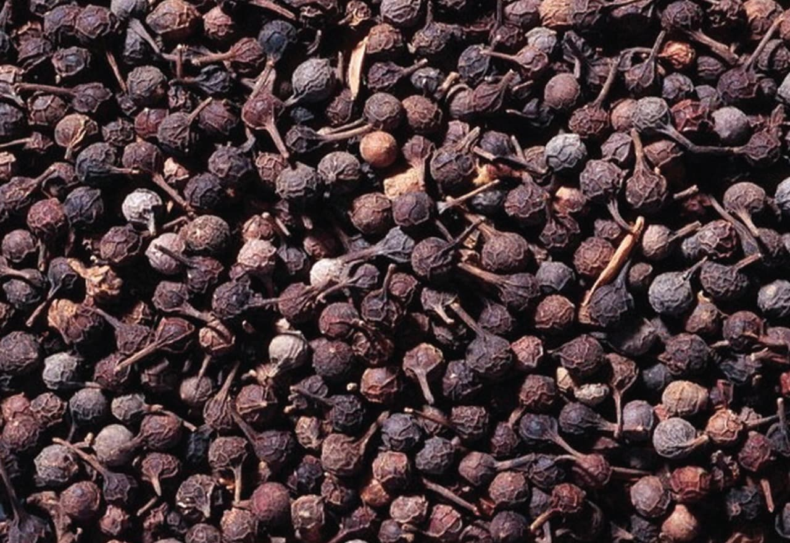
CUBEB PEPPER (KEMUKUS)
Rare Indonesian cubeb pepper with distinctive tail and complex flavor profile. Sought after for specialty spice blends and traditional medicine applications.
- Moisture Content: Max 13%
- Essential Oil Content: Min. 10%
- Purity: 98% (With characteristic tail)
- Quality Grade: Premium Wild Harvest

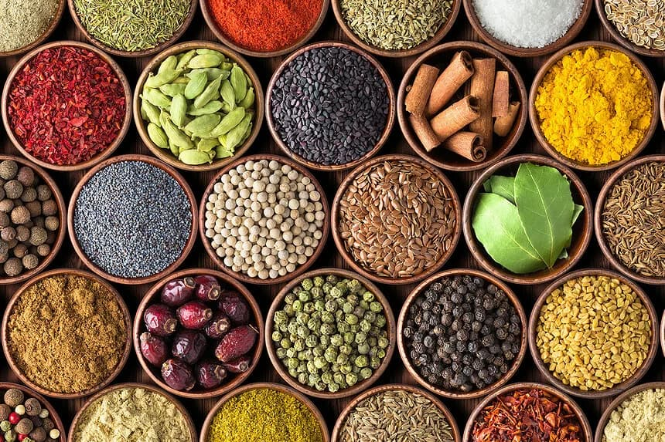
OTHER SPICES (ETC)
We also supply a wide range of other premium Indonesian spices including white pepper, black pepper, cinnamon, cardamom, and more. Contact us for specific requirements.
- Various spice varieties available
- Custom processing and packaging
- Certified quality standards
- Flexible order quantities

